25.49: a)
b) The power dissipated in the battery is 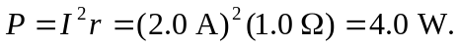
c) The power delivered is then 

